

**Version History**

**SCTK2269-** **BRS – IFC Module V1**

Version : 1.0

Document Type : Knowledge Document

Created By : Raj Kumar K

Reviewed By : Subramanya Raju

Reviewed Date : 26-12-2023

BRS – IFC Module – Carelon V1

|  |  |  |  |  |  |  |
| --- | --- | --- | --- | --- | --- | --- |
| **Date** | **Version** | **Creator** | **Reviewer** | **Approver** | **UAT POC** | **History Details** |
| 26-Dec-23 | 1 | Raj Kumar K | Subramanya R | Raj Kumar K | Lakshman BS | Creation |
|  |  |  |  |  |  |  |
|  |  |  |  |  |  |  |

Table of Contents

**1.** **Introduction:** 4

**2.** **Page:** 4

1. **Introduction:**
   1. The document describes the requirement of Simpliance ICM (IFC) for the client Carelon Global Solutions.
2. **Requirements:** 
   1. Provide a option to create a minimum of 100 controls using bulk upload with the values present in the page “internal_task_add”. To handle “Test Flow” and “Sample Uploads” use the logic as mentioned below.
      1. Test Flow, use the existing Test Flow which present for all the reviews and should be mandate to update for control creation.
      2. Sample Uploads, give a provision in template to choose Sample Upload values for at least 2 inputs and should be mandate to update for control creation.

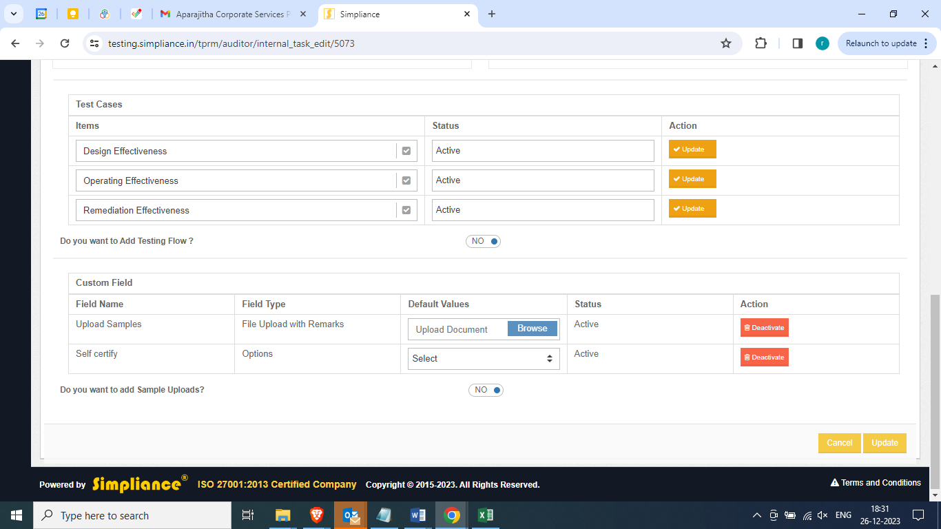

* 1. Replace the header from “Manual/Automated” to “Control Type” and add drop down with the options – 1) Automated 2) Manual 3) IT dependent.

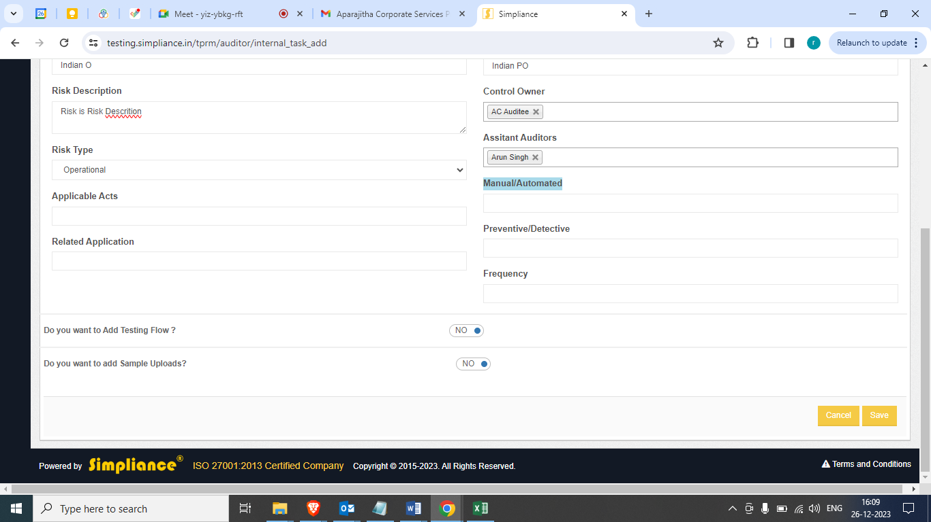

* 1. Add new header called “Key/Non-Key” and add Key and Non-Key as a radio button to choose and mandate before creating any new controls.
  2. Provide a option to Assistant Auditor role for creating/add reviews like as Auditor.
  3. Once the auditor selects "I’m not the control owner of the listed controls" next attestation should not be appeared for selections and provide a option to submit the review.

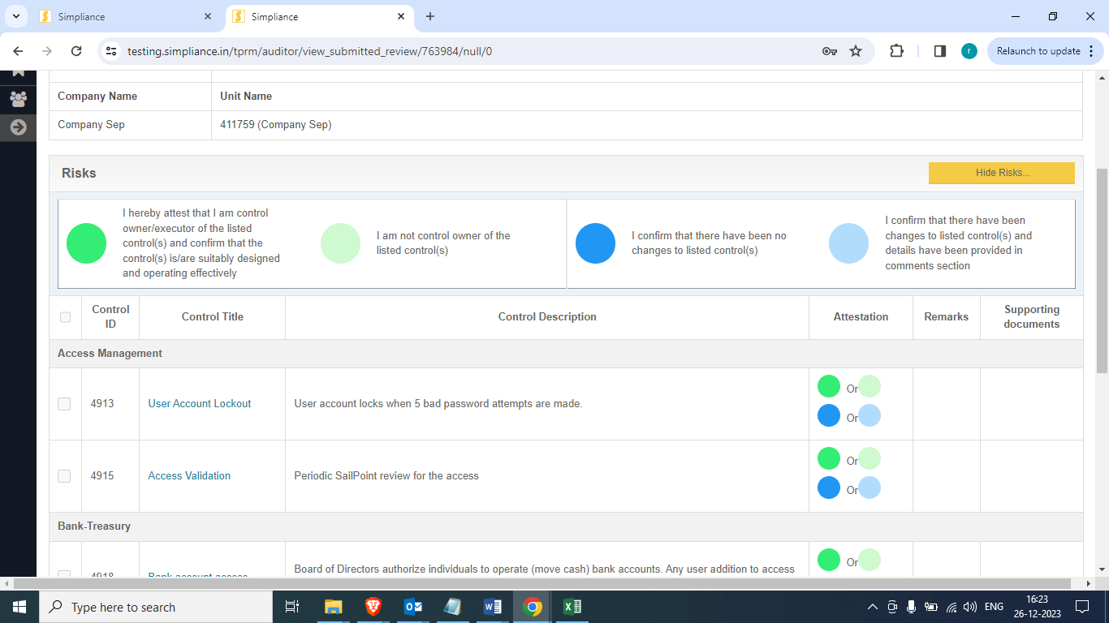

* 1. Provide a option to Reopen the review to Auditor and Asst. Auditor.
  2. Rename the header section

**From**: “I confirm that there have been changes to listed control(s) and details have been provided in comments section.”

**To**: “I confirm that there have been changes to listed control(s) and details have been provided in Remarks section.”



*** End of document ***